Setup minikube at your local and explore creating namespaces

1. **Install Minikube**

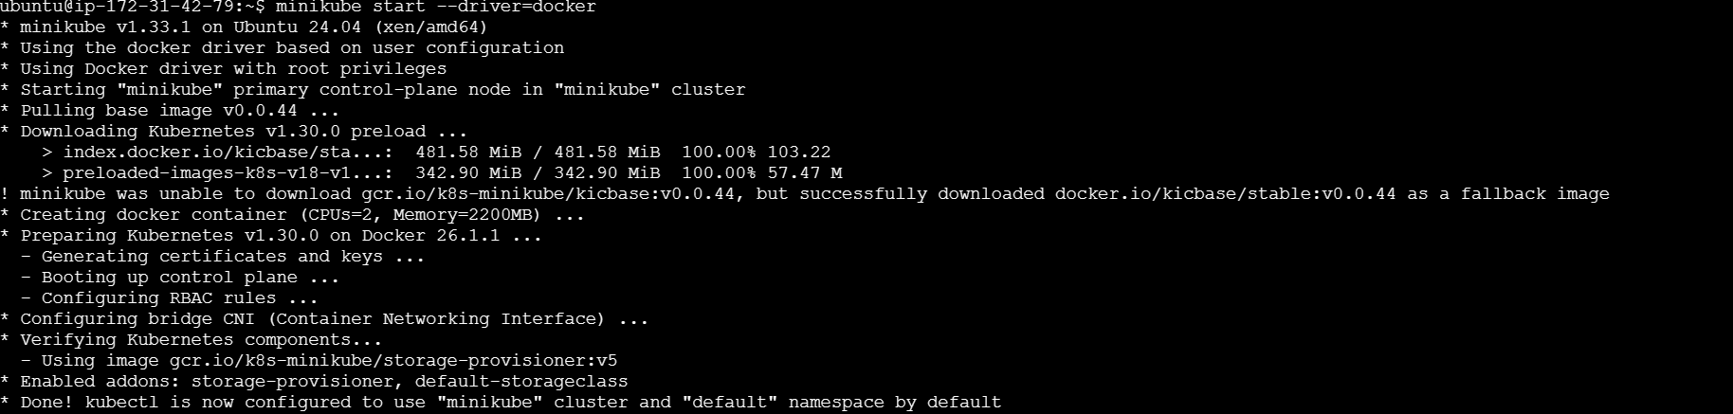

1. **Create Namespace Demo**



1. **Namespace details**



